Julian Kotara
Sandra Vasconez
Landscape and Exterior Lighting
25 August 2026

Explain how the metaphor "...just as furniture and accessories complete the view of an interior space" relates to plants used in a landscape.
When looking at a crafted and designed exterior landscape, the plants are additions to the space that do a lot of the heavy lifting in creating a specific feeling or organization of the space. Just as an empty room comes to life with furniture and other accessories, a boring plot of grass can be dramatically improved by thoughtfully placed trees and plants.

Why is it important to study all the plants in a landscape when thinking of illuminating them?
Every plant will likely play a role in the landscape, whether they are a focal point or solely used to conceal a fixture from view. Because of the plants different roles in the space, it’s important to understand what plants have what qualities and use them to the advantage of the space. For example, a very sparse shrub would do a poor job blocking a fixture pointing toward to viewer, however it could be used to conceal a driver box or other electrical equipment.

Provide working definitions of the words 'genus', 'species' and 'variety'. By working definition, I don't mean a dictionary-type definition, but what does it actually mean to you the lighting designer when considering the characteristics of specific trees? There are nuances that Ms. Moyer explains outside of just defining these words. Show that you understand the words and their nuances.
Genus, species, and variety help define that kinds of plants in a landscape design, with each successive word better defining what the plant, and subsequent lighting strategy, will be. For a genus, such as a pine tree, it allows a very rough idea of the lighting style (like lighting the trunk due to thinner foliage) and starts to eliminate lighting styles that obviously won’t work. As the plant is further defined by the species, the designer can begin to approximate size, height, and specific characteristics of the tree, allowing for aiming angles, color temperatures, or other more definite lighting characteristics to be chosen. Lastly, the variety fully defines the plant, letting the lighting designer finalize aiming directions, fixture specifications, and locations on the plan to truly build out their vision for the landscape.

Explore on the internet one set of trees as shown in figures 14.7, 14.8, or 14.9. In other words, choose one figure and explore the trees described. Provide photos of those trees along with relevant captions and references.
The cypress tree, often found in Italy, is well know for its unique slender profile and are often seen lining country roads across the country. However, in more rugged parts of Italian mountain ranges, they can often spread out horizontally (seen in the middle picture). On the right is the Arizona Cypress (most commonly found in central Mexico), a large more oval profile distinctly separates it from the slender Italian Cypress.
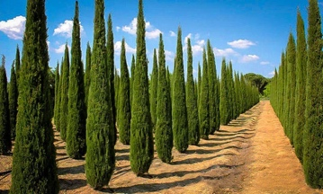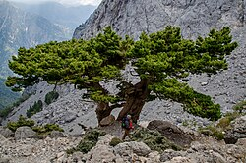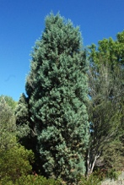
Left to Right: Italian Cypress, Italian Cypress in the mountains, Arizona Cypress
https://en.wikipedia.org/wiki/Cupressus_sempervirens
https://en.wikipedia.org/wiki/Hesperocyparis_arizonica

What is the importance of listing plants by caliper to you, the lighting designer? Explain.
It allows lighting designers to get a good idea of the actual size and shape of the tree if photos are not available. By having somewhat standard containers, or actual measurements, the designer can understand if the tree can support lighting equipment, how to light it, and what role the plant will play on the site.

What are the four general tree shapes shown in figures 14.10, 14.11, 14.12 and 14.13? Briefly describe them and provide a visual example of each. My preference would be for you to take your own photographs of trees you see on campus or in your neighborhood.
(from previous photos I have taken)
Ball and Round Shape
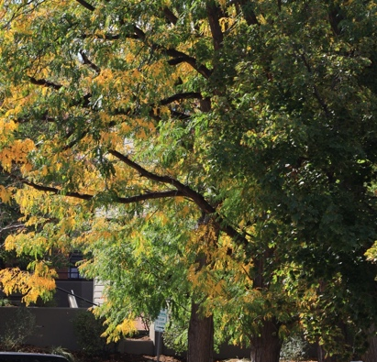

Pyramidal, Columnar, Upright Shape


Vase, Fountian, Umbrella Shape
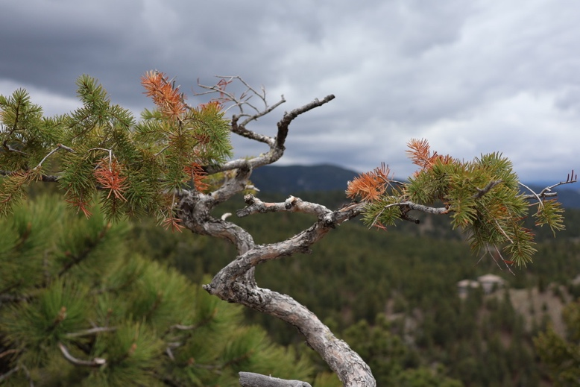

Weeping and Branching to Ground Shape
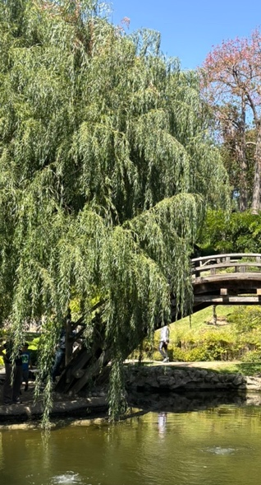

Take a look at figure 14.17. What is Mr. Moyer's point about deciduous trees when it comes to illuminating them?
With deciduous trees losing their leaves in the winter, it can completely change the look of the tree. With flowering dogwood, the tree is much more interesting during the summer with the leaves on the tree, so lighting this during the summer months or only in warmer climates would be a good option. However, some trees like the Lauders walking stick have interesting branch patterns that evoke more interest in the winter due to their lack of leaves. If the controls are available, lighting the tree more brightly in the winter and more subdued in the summer would be the best option.

What are the general types of barks? Some of these are common in our area but others are not. Since you may not find some of them around, you may look online to find visual examples. Provide relevant captions and references.
Thorned
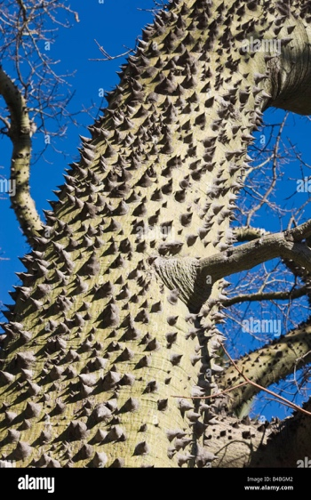
Chorisia Insignis Truck (https://www.alamy.com/stock-photo/trunk-of-chorisia-insignis-tree.html)

Stripped/Patterned
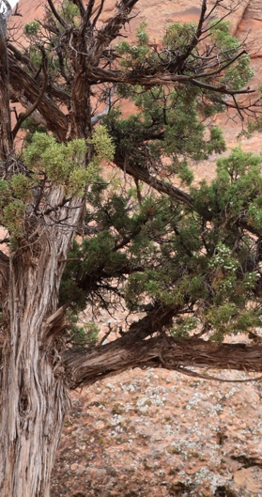
Utah Juniper (Arches National Park by me)

Peeling/Flaking
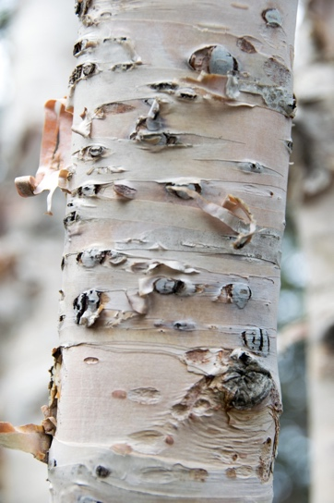
Paperbark Birch Tree (https://plants.ces.ncsu.edu/plants/betula-papyrifera/ )

Mottled
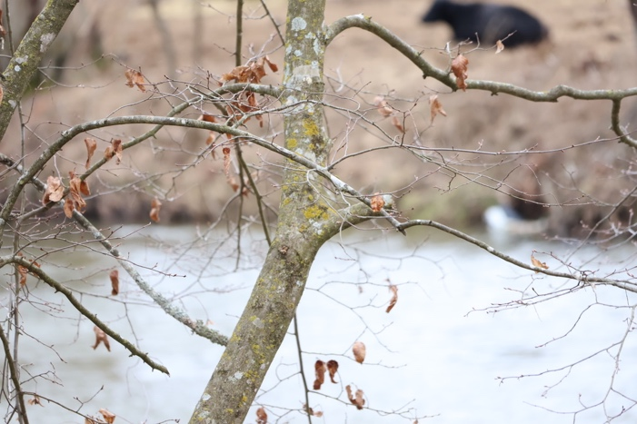
American Beech Tree (Clyde, NC by me)

Furrowed/Cracked
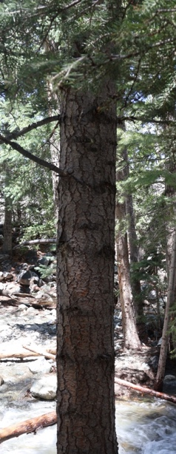
Douglas Fir (Zapata Falls, CO by me)

